# MEHRAN UNIVERSITY OF ENGINEERING AND TECHNOLOGY, JAMSHORO

**DEPARTMENT OF ELECTRONIC**

**ENGINEERING**

**Project Report**

# ‘ECG WAVE SIMULATOR USING OP-AMP’

**FOR THE SUBJECT**

‘Digital Electronics’

**SUBMITTED BY**

**Ahmed Bux Chandio (20ES036)**

**Karan Kumar (20ES062)**

## **Usama Atta Abbasi (20ES070) Yasir Salah Junejo (20ES072)**

**SUBMITTED TO**

**Prof: Dr Khalil ur Rehman Dayo**

# CONTENTS

|  |  |  |
| --- | --- | --- |
| **SR.NO** | **SUBHEADING NAMES** | **PAGE NO** |
| 1 | INTRODUCTION | 3 |
| 2 | PROJECT IDEA | 3 |
| 3 | COMPONENT LIST | 4 |
| 4 | DESCRIPTION OF COMPONENT | 4-5 |
| 5 | CIRCUIT DIAGRAM | 6 |
| 6 | METHODOLOGY | 6-8 |
| 8 | RESULT | 9 |
| 9 | APPLICATION | 10 |

## INTRODUCTION

A common test to state and diagnose the working condition of the heart is done with the assistance of electrocardiogram (ECG), where the rhythm and activity of the heart is recorded on a moving strip of paper or displayed as a line on a screen of the ECG Transient. The doctor can interpret the data thus obtained and analyze the peaks and dips on paper or screen, to test any abnormal or unusual activity in the heart. For the above mentioned analysis it is prerequisite to grasp the knowledge, characteristics and appearance of such ECG waveform in various medical colleges and laboratories. Therefore, electronic biomedical signal source or signal generators were used to generate biomedical signals. The heart signal is called as PQRST wave which has many peaks and troughs. A trial and ventricular depolarization and repolarization are responsible for the generation of the ECG signal. The senatorial node in the heart creates a small electrical signal which is responsible for these depolarization and depolarization. ECG is represented as a series of waves: the P wave followed by the QRS complex and the T wave. The J point is found at the junction of the QRS complex and the beginning of the ST segment.

## PROJECT IDEA

ECG simulator intended to use in testing, calibration and maintenance of electrocardiographic equipment, and to support biomedical engineering students' education. It generates all 12 healthy ECG derivation signals having a profile that varies with heart rate, amplitude, and different noise contamination in a manner which reflects true in vivo conditions. The heart rate can be set at the range of 30 to 120 beats/minute in four steps. The noise and power line interference effects can be set at the range of 0 to 20 dB in three steps. Since standard commercially available electronic components were used to construct the prototype simulator, the proposed design was also relatively inexpensive to produce.

## COMPONENT LIST

The list of components used in my project in a numbered list.

1. Op-Amp

i) ADC20AN ii) OP07AJ iii) OP07CP iv) OPA2130PA

1. Resistors
2. Capacitors
3. Piecewise voltage

## DISCRIPTION OF COMPONENT

### 1. OPERATIONAL-AMPLIFIER:-

An operational amplifier (op-amp) is a DC-coupled high-gain electronic voltage amplifier with a differential input and typically a single-ended output. The output voltage an op-amp produces is typically hundreds of thousands of times larger than the voltage difference between its input terminals.

Characteristics of a circuit using an op-amp are set by external components with little dependence on temperature changes or manufacturing variations in the opamp itself, which makes op-amps popular building blocks for circuit design.

The operational amplifier is one of the most useful and important components of analog electronics. Op-amps are widely used in consumer, industrial, and scientific devices.

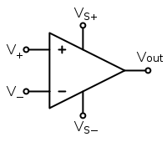*Op Amp Symbol*

The circuit symbol for an op-amp is shown to the right, where:

* V+: non-inverting input
* V−: inverting input
* Vought: output
* VS+: positive power supply
* VS−: negative power supply

Where

* V+ is the voltage at the non-inverting terminal, V− is the voltage at the inverting terminal and AOL is the open-loop gain of the amplifier.
* The Vought voltage range is limited by the power supply voltages to VS+ and VS-.

### 2. RESISTOR:-

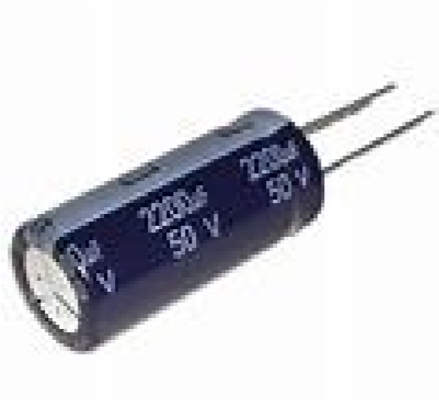

A resistor is a passive two-terminal electrical component that implements electrical resistance as a circuit element. In electronic circuits, resistors are used to reduce current flow, adjust signal levels, to divide voltages, bias active elements, and terminate transmission lines, among other uses.

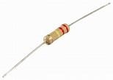

### 3. CAPACITOR:-

Capacitorsstoreanelectricalchargeusingextremelythinandtightlywoundelectricc onductorsseparatedbyaninsulator.Thiscanbeanelectrolyte, mica, or several other types of materials. While they do not allow a direct current (DC) signal to pass, they do allow alternating current (AC) voltage & signals to pass.

## CIRCUIT DIAGRAM

METHODOLOGY

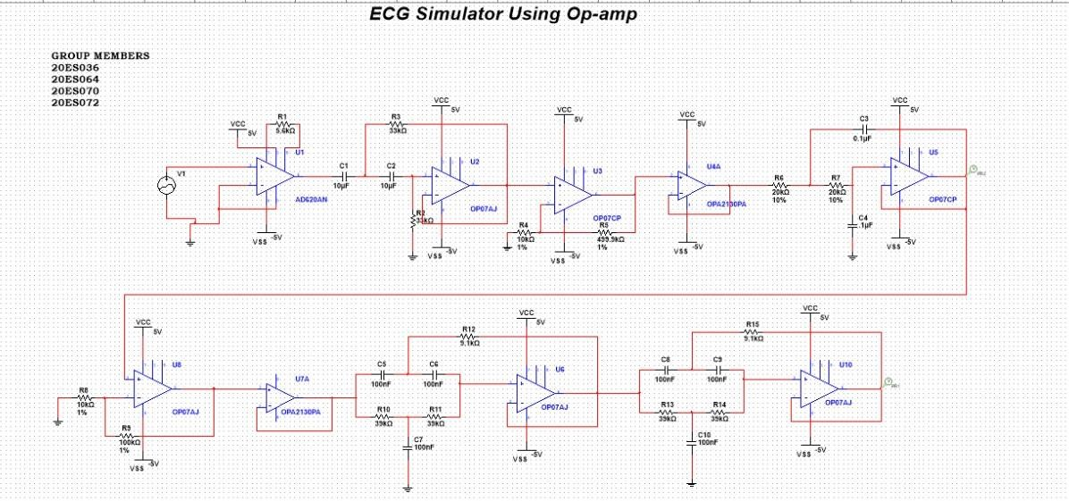

The process of producing an electrocardiogram (ECG), a recording of a graph consists of [voltage v](https://en.wikipedia.org/wiki/Voltage)ersus time which represents the electrical activity of the [heart u](https://en.wikipedia.org/wiki/Heart)sing [electrodes p](https://en.wikipedia.org/wiki/Electrode)laced on the skin is known as Electrocardiography. Leads from an electrocardiograph transient are placed on the patient’s skin at various places like legs, chest, hands, and on the ribs using sticky patches (electrodes). These electrodes placed on the skin can detect the small electrical changes which were due to [depolarization a](https://en.wikipedia.org/wiki/Depolarization)nd [re-polarization o](https://en.wikipedia.org/wiki/Repolarization)f the heart muscle during each cardiac cycle (heartbeat). Any deviation from the normal ECG pattern denote the cardiac abnormalities, like cardiac rhythm disturbances (such as [atrial fibrillation a](https://en.wikipedia.org/wiki/Atrial_fibrillation)nd [ventricular tachycardia)](https://en.wikipedia.org/wiki/Ventricular_tachycardia), inadequate blood flow to coronary artery (such as [myocardial ischemia a](https://en.wikipedia.org/wiki/Myocardial_ischemia)nd [myocardial infarction)](https://en.wikipedia.org/wiki/Myocardial_infarction), and disturbances in the electrolyte in the node.

The printed ECG signal on a paper strip or visual appearance on the screen of Transient is shown in Fig1

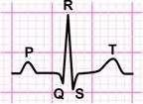

***Fig.***

***1***

***ECG***

***Printed***

***Paper***

An electrocardiograph transient are placed on the patient’s skin at various places like legs, chest, hands, and on the ribs using sticky patches (electrodes).

In our circuit we used different op amps mentioned above, as differentiator, integrator and buffers as ECG basically gives difference of different signals our circuit also do same beside differentiator we used integrator to make a single output waveform to observe condition of patient which can be diagnosed by the doctor.

Following pictures shows different values we taken as input to the device we have taken one input voltage values here in real there are 3 inputs but as simulation we taken 1 to make circuit easy to understand.

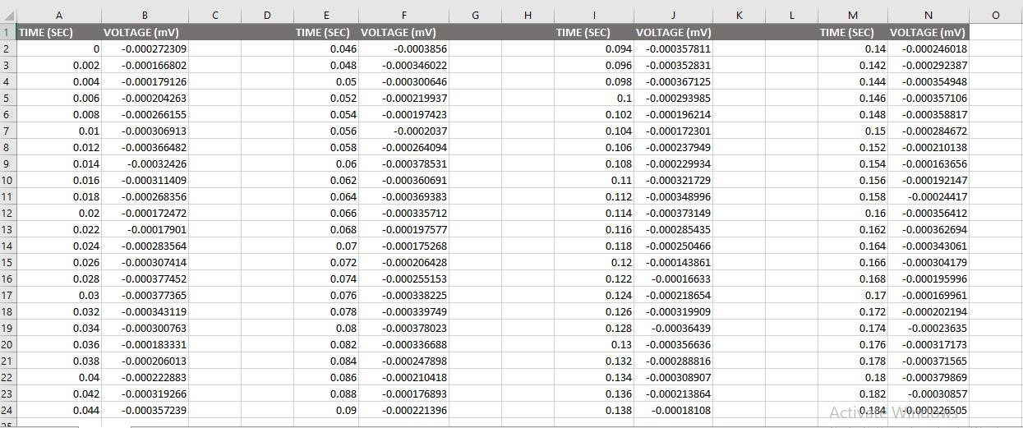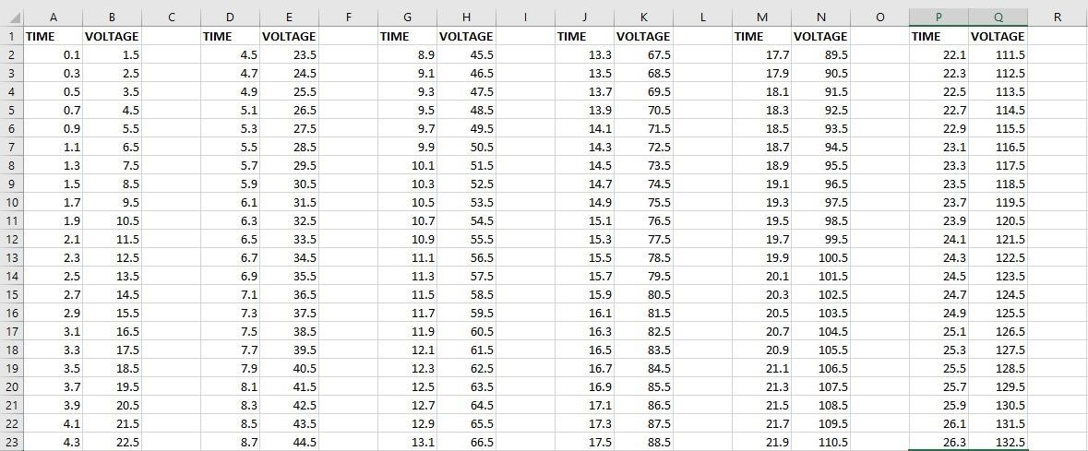

## RESULT

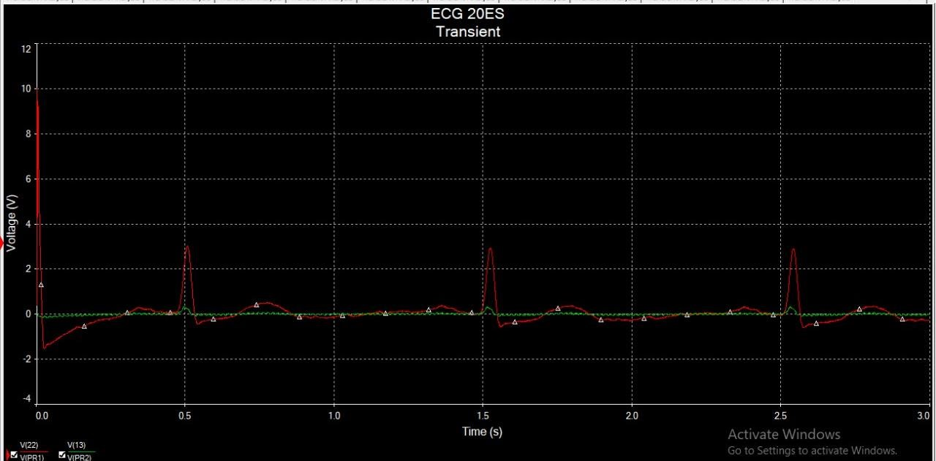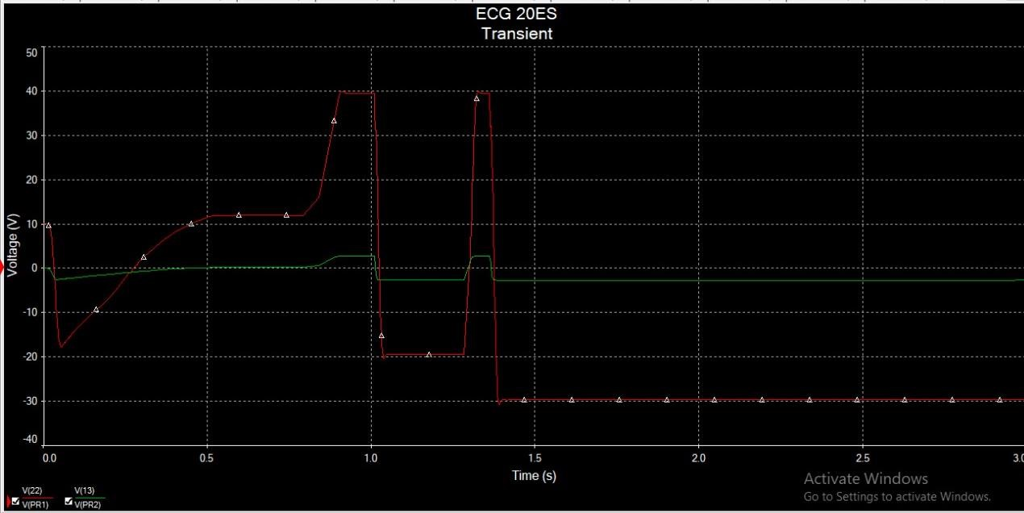

**|** P a g e

## APPLICATION

An electrocardiogram (ECG) records the electrical signal from your heart to check for different heart conditions. Electrodes are placed on your chest to record your heart’s electrical signals, which cause your heart to beat.